**Heap**

**public** **class** Heap {

**int** maxSize;

**int** n;

**int** heap[];

Heap() {

maxSize = 50;

n = 0;

heap = **new** **int**[maxSize];

}

**void** insertHeap(**int** item) {

**int** i;

**if** (n == maxSize)

System.***out***.println("heapFull!");

n = n + 1;

**for** (i = n;;) {

**if** (i == 1)

**break**;

**if** (item <= heap[i / 2])

**break**;

heap[i] = heap[i / 2];

i = i / 2;

}

heap[i] = item;

}

**public** **void** printHeap() {

**for** (**int** i = 1; i <= n; i++) {

System.***out***.print(heap[i] + " ");

}

System.***out***.println();

}

Object deletdHeap() {

**int** item, temp, i = 1, j = 2;

**if** (n == 0)

**return** **null**;

item = heap[1];

temp = heap[n];

n = n - 1;

**while** (j <= n) {

**if** (j < n) {

**if** (heap[j] < heap[j + 1]) {

j = j + 1;

}

}

**if** (temp >= heap[j]) {

**break**;

}

heap[i] = heap[j];

i = j;

j = j * 2;

}

heap[i] = temp;

**return** item;

}

**void** makeTreeHeap(**int** H[], **int** n) {

**int** p,temp;

**for**(**int** i = n/2;i>=1;i=i-1){

p=i;

**for**(**int** j = 2*p;j<=n;j=j*2){

**if**(j<n){

**if**(H[j]<H[j+1]){

j=j+1;

}

**if**(H[p]>=H[j]){

**break**;

}

temp = H[p];

H[p] = H[j];

H[j] = temp;

p = j;

}

}

}

System.***out***.println("변환된 히프의 값");

**for** (**int** i = 1; i < n+1; i++) {

System.***out***.print(H[i] + " ");

}

System.***out***.println();

}

}

HeapTest

**public** **class** HeapTest {

**public** **static** **void** main(String[] args) {

// **TODO** Auto-generated method stub

Heap hp = **new** Heap();

hp.insertHeap(18);

hp.insertHeap(13);

hp.insertHeap(5);

hp.insertHeap(12);

hp.insertHeap(8);

hp.insertHeap(19);

System.***out***.print("입력 된 값: ");

hp.printHeap();

System.***out***.println("");

**boolean** a = **true**;

Object ob;

**while**(a){

ob = hp.deletdHeap();

**if**(ob != **null**){

System.***out***.println("삭제 된 값: "+ob);

System.***out***.print("삭제 후 값: ");

hp.printHeap();

System.***out***.println("");

}**else**{

a = **false**;

}

}

}

}

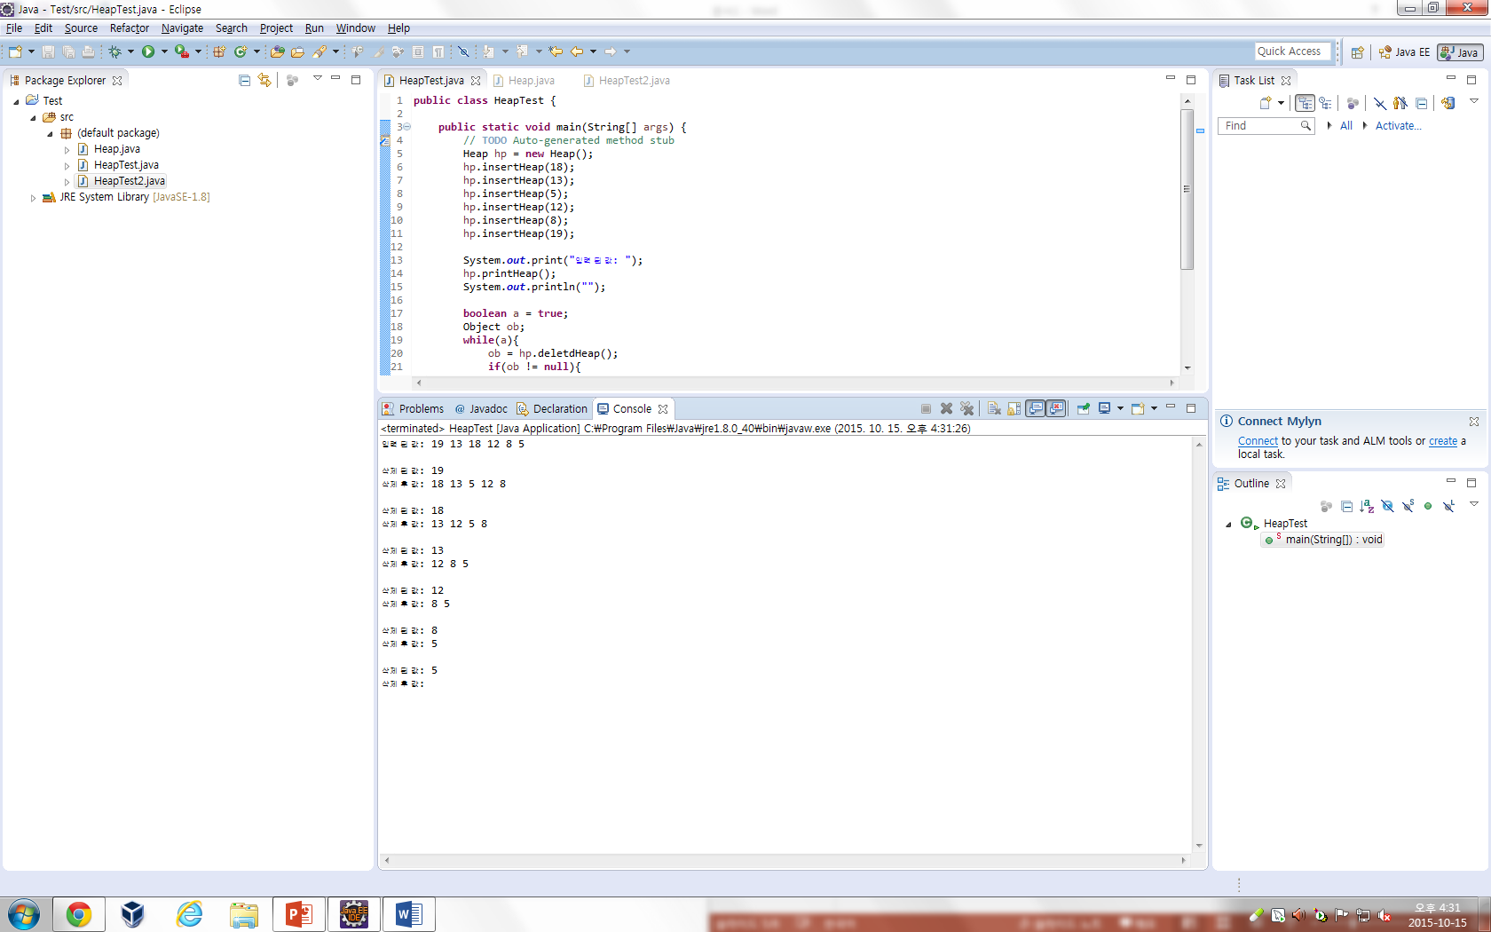

HeapTest2

**public** **class** HeapTest2 {

**public** **static** **void** main(String[] args) {

// **TODO** Auto-generated method stub

Heap hp2 = **new** Heap();

**int** a[] = {0,15,11,70,5,13,50};

System.***out***.println("완전이진트리의 값");

**for**(**int** i = 1; i<a.length;i++){

System.***out***.print(a[i]+" ");

}

System.***out***.println("\n");

hp2.makeTreeHeap(a,a.length-1);

}

}

